Department of Defense (DoD)
Information Assurance Certification and Accreditation Process (DIACAP)

AUDIT Subsystem Artifact
VERSION 1.0.0

FOR

<SYSTEM NAME>

<INSERT CLIENT LOGO>

DISTRIBUTION IS LIMITED TO U.S. GOVERNMENT AGENCIES AND THEIR CONTRACTORS.
OTHER REQUESTS FOR THIS DOCUMENT MUST BE REFERRED TO: <CLIENT>
Template developed by: I-Assure, LLC. http://www.i-assure.com

This page intentionally blank

change log
This record shall be maintained throughout the life of the document. Each published update shall be recorded. Revisions are a complete re-issue of entire document. A revision shall be made whenever the cumulative changes reaches ten percent (10%) of this document’s content.
CHANGE / REVISION RECORD
Date | Page/Paragraph | Description of Change | Made By:

tABLE OF CONTENTS
1. overview 2
2. introduction 2
3. audit Architecture 2
3.1 Overview 2
3.2 <SYSTEM NAME> Audit Implementation 3
3.3 Audit Devices 4
3.3.1 Cisco ASA Firewall/IDS 4
3.3.2 Cisco Router 6
3.3.3 Cisco Switches 7
3.3.4 Windows Servers 7
3.3.5 Microsoft SQL Server 9
3.3.6 Microsoft IIS Server 9
4. Audit Content (ECAR-1, ECAR-2, ECAR-3, ECLC-1) 10
5. Audit Reduction and Report Generation (ECRG-1) 11
5.1 Event Severity Reports 11
5.2 User Access Reports 12
5.3 Custom Reports 13
6. Audit Record Retention (ECRR-1) 14
7. audit Trail Protection (ECTP-1) 15
8. Audit Trail Backup (ECTB-1) 16
9. Audit Review (ECAT-1, ECAT-2) 16

executive summary

The following table lists the DoDI 8500.2 IA Controls that are satisfied through this artifact.
IA Control Number | IA Control Name
ECAT-1, ECAT-2 | Audit Trail, Monitoring, Analysis and Reporting
ECLC-1 | Audit Record Content – Classified Systems Audit of Security Label Changes
ECAR-1  ECAR-2  ECAR-3 | Audit Record Content – Public Systems  Audit Record Content – Sensitive Systems  Audit Record Content – Classified Systems Audit of Security Label Changes
ECRG-1 | Audit Reduction and Report Generation
ECRR-1 | Audit Record Retention
ECTP-1 | Audit Trail Protection
ECTB-1 | Audit Trail Backup

overview
<INSERT SYSTEM OVERVIEW>

introduction
Audit trails maintain a record of system activity both by system and application processes and by user activity of systems and applications. In conjunction with appropriate tools and procedures, audit trails can assist in detecting security violations, performance problems, and flaws in applications.

An audit trail is a series of records of computer events, about an operating system, an application, or user activities. A computer system may have several audit trails, each devoted to a particular type of activity. Auditing is a review and analysis of management, operational, and technical controls. The auditor can obtain valuable information about activity on a computer system from the audit trail. Audit trails improve the auditability of the computer system.

Audit trails may be used as either a support for regular system operations or a kind of insurance policy or as both of these. As insurance, audit trails are maintained but are not used unless needed, such as after a system outage. As a support for operations, audit trails are used to help
system administrators ensure that the system or resources have not been harmed by hackers, insiders, or technical problems.

audit Architecture

Overview
<SYSTEM NAME> utilizes EventLog Analyzer for centralized audit collection. EventLog Analyzer is a web-based, real-time, event monitoring and management solution that improves security and reduces downtime of distributed servers and workstations on your enterprise network. It collects event logs from distributed Windows Servers, Routers & Switches, and other syslog devices using an agent-less architecture and generates graphs and reports that help in analyzing system problems with least impact on network performance. The following diagram is a high level overview of the EventLog Analyzer system.
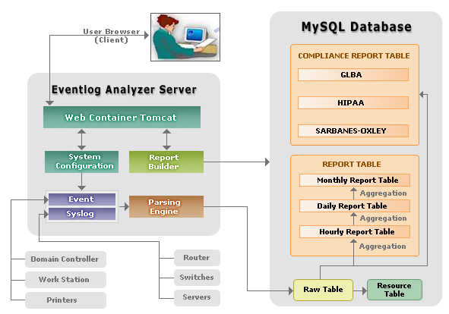

<SYSTEM NAME> Audit Implementation
All <SYSTEM NAME> network devices utilize SYSLOG to transfer logging and audit information to the EventLog Analyzer server. <SYSTEM NAME> Windows logs are pulled via RPC with Active Directory to the EventLog Analyzer server. Once the data is located on the collection server, a standard web browser is used to view information, alerts, trends and create reports.
(INSERT AUDIT FLOW DIAGRAM>

Audit Devices

Cisco ASA Firewall/IDS
The <SYSTEM NAME> Cisco ASA firewall has been configured to forward SYSLOG events to the EventLog Analyzer by executing the following configuration using a Level 6 logging facility, which incorporates all Level 1-6 facilities:
Step | Command | Purpose
1 | firewall# config terminal | Enters global configuration mode
2 | firewall(config)#logging timestamp | Specifies that each syslog message should have a timestamp value
3 | firewall(config)#logging host [interface connected to syslog server] ip_address [protocol / port] | Specifies a syslog server that is to receive the messages sent from the Cisco ASA.
4 | firewall(config)#logging facility facility | Specifies the syslog facility number. Instead of specifying the name, the ASA uses a 2-digit number, as follows:  local0 - 16  local1 - 17  local2 - 18  local3 - 19  local4 - 20  local5 - 21  local6 - 22  local7 - 23
5 | firewall(config)#logging trap level | Specifies the syslog message level as a number or string. The level that you specify means that you want that level and those values less than that level. Possible number and string level values are as follows:  0: Emergency; System-unusable messages  1: Alert; Take immediate action  2: Critical; critical condition  3: Error; error message  4: Warning; warning message  5: Notice; normal but significant condition  6: Informational: information message  7: Debug; debug messages
6 | firewall(config)#logging on | Starts sending syslog messages to all output locations
7 | firewall(config)#no logging message <message id> | Specifies a message to be suppressed
8 | firewall(config)#exit | Exits global configuration mode

Cisco Router
The <SYSTEM NAME> Cisco <version> Router has been configured to forward SYSLOG events to the EventLog Analyzer by executing the following configuration using a Level 6 logging facility, which incorporates all Level 1-6 facilities:
Step | Command | Purpose
1 | Router# configure terminal | Enters global configuration mode
2 | Router(config)# service timestamps type datetime [msec] [localtime] [show-timezone] | Instructs the system to timestamp syslog messages
3 | Router(config)#logging host | Specifies the syslog server by IP address or host name; you can specify multiple servers
4 | Router(config)# logging trap level | Specifies the kind of messages, by severity level, to be sent to the syslog server  Emergency: 0  Alert: 1  Critical: 2  Error: 3  Warning: 4  Notice: 5  Informational: 6  Debug: 7
5 | Router(config)# logging facility facility-type | Specifies the facility level used by the syslog messages; the default is local7. Possible values are local0, local1, local2, local3, local4, local5, local6, and local7
6 | Router(config)# End | Returns to privileged EXEC mode
7 | Router# show logging | Displays logging configuration

Cisco Switches
The <SYSTEM NAME> Cisco <version> Switches have been configured to forward SYSLOG events to the EventLog Analyzer by executing the following configuration using a Level 6 logging facility, which incorporates all Level 1-6 facilities:
Step | Command | Purpose
1 | Switch>(enable) set logging timestamp {enable | disable} | Configures the system to timestamp messages
2 | Switch>(enable) set logging server ip-address | Specifies the IP address of the syslog server; a maximum of three servers can be specified
3 | Switch>(enable) set logging server severity server_severity_level | Limits messages that are logged to the syslog servers by severity level
4 | Switch>(enable) set logging server facility server_facility_parameter | Specifies the facility level that would be used in the message
5 | Switch>(enable) set logging server enable | Enables the switch to send syslog messages to the syslog servers
6 | Switch>(enable) Show logging | Displays the logging configuration

Windows Servers
The EventLog Analyzer subsystem is used to facilitate remote, real-time transfer of event log information. Event logs from the Security, Application and System logs, as well as the new DNS, File Replication Service, and Active Directory logs are supported.

The following Event categories are captured. A detailed listing of all Event IDs and description is found in Appendix

- Logon of Logoff. This will trap the following events: '528, 529, 530, 531, 532, 533, 534, 535, 536, 537, 538, 539, 540, 541, 542, 543, 544, 545, 546, 547, 672, 673, 674, 675, 676, 677, 678, 680, 681, 682, 683'

- Access a file or directory. This will trap the following events: '560, 561, 562, 563, 564, 565, 566, 594, 595'

- Start or stop a process. This will trap the following events: '592, 593, 594, 595'

- Use of user rights. This will trap the following events: '576, 577, 578, 608, 609'

- Account administration. This will trap the following events: '624, 625, 626, 627, 628, 629, 630, 631, 632, 633, 634, 635, 636, 637, 638, 639, 640, 641, 642, 643, 644, 645, 646, 647, 648, 649, 650, 651, 652, 653, 654, 655, 656, 657, 658, 659, 660, 661, 662, 663, 664, 665, 666, 667, 668, 669, 670'

- Change the security policy. This will trap the following events: '516, 517, 608, 609, 610, 611, 612, 613, 614, 615, 616, 617, 618, 620, 643'

- Restart, shutdown and system. This will trap the following events: '512, 513'

The EventLog Analyzer captures the following event log information:

- Hostname. This is the Windows computer name.

- Event Log Type.

- Criticality.

- SourceName. This is the Windows Event Log from which the event record was derived.

- DateTime. This is the date time stamp of the event record.

- EventID. This is the Windows Event ID.

- UserName. This is the Window's user name.

- SIDType. This is the type of SID used.

- EventLogType. This can be anyone of 'Success Audit', 'Failure Audit', 'Error', 'Information', or 'Warning'.

- CategoryString. This is the category of audit event, as detailed by the Windows event logging system.

- DataString. This contains the data strings.

- ExpandedString. This contains the expanded data strings

Microsoft SQL Server
The <SYSTEM NAME> Microsoft SQL 2005 Server sends all event information to the Microsoft Event Log described in Section 3.3.4, which in turn send the event information to the EventLog Analyzer.

Microsoft IIS Server
The <SYSTEM NAME> Internet Information Server (IIS) web sites have been configured for “Extended Logging”. <SYSTEM NAME> hosts multiple web sites, therefore W3C centralized logging has been configure so that all Web sites write data to a single log file using the following command:
From a command prompt, type Adsutil.vbs set w3svc/CentralW3CLoggingEnabled true

The IIS Log File is stored in the Windows/system32/logfiles/W3SVC directory and contains the following information:
Field | Appears As | Description
Date | date | The date on which the activity occurred.
Time | time | The time, in coordinated universal time (UTC), at which the activity occurred.
Client IP Address | c-ip | The IP address of the client that made the request.
User Name | cs-username | The name of the authenticated user who accessed your server. Anonymous users are indicated by a hyphen.
Server IP Address | s-ip | The IP address of the server on which the log file entry was generated.
Server Port | s-port | The server port number that is configured for the service.
Method | cs-method | The requested action, for example, a GET method.
URI Stem | cs-uri-stem | The target of the action, for example, Default.htm.
URI Query | cs-uri-query | The query, if any, that the client was trying to perform. A Universal Resource Identifier (URI) query is necessary only for dynamic pages.
HTTP Status | sc-status | The HTTP status code.
User Agent | cs(User-Agent) | The browser type that the client used.
Protocol Substatus | sc-substatus | The substatus error code.

To integrate the IIS Log Files into the centralized EventLog Analyzer, <SYSTEM NAME> has implemented the Snare for IIS product developed by InterSect Alliance. Snare for IIS provides a remote distribution facility for IIS web server logs that converts the text-based file to SYSLOG messages that are then sent to the central logging facility for collection, analysis, and archival.

Audit Content (ECAR-1, ECAR-2, ECAR-3, ECLC-1)
<SYSTEM NAME> audit records include the following information:

- User ID.
- Successful and unsuccessful attempts to access security files (e.g.. audit records, password files, access control files)
- Date and time of the event.
- Type of event.
- Success or failure of event.
- Successful and unsuccessful logons.
- Denial of access resulting from excessive number of logon attempts.
- Blocking or blacklisting a user ID, terminal or access port and the reason for the action.
- Activities that might modify, bypass, or negate safeguards controlled by the system (system administrator logon, logging directly onto a router vs. using TACACS+, altering access control lists, or altering security files).
- Accounts creation or deletion
- Identity of the IS Component where the event occurred.

Audit Reduction and Report Generation (ECRG-1)
<SYSTEM NAME> EventLog Analyze’s high-performance architecture enables unique alerting algorithms and can process all log messages in real-time, including the highest volume informational level messages. Device-specific alerts warn administrators of rate-based, policy-based or message-code anomalies. Both behavioral modeling and rules-based alerts are available. Real-time reporting and targeted queries make log data instantly searchable and insightful. Analysis can be performed by an administrator at the remote site or by a central administrator using a web-based console.
The following types of reporting capabilities are available:

Event Severity Reports
Hosts and processes generating maximum number of events in each severity can be easily viewed. The following diagram depicts an example of this report.
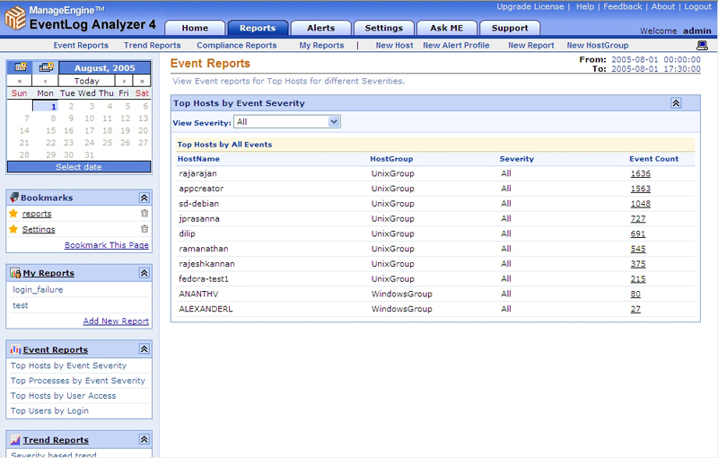

User Access Reports
Hosts generating maximum number of successful and failed login events can be easily viewed. While successful login events on a host is a useful metric to track host usage trends, failed login attempts on a host is important in analyzing hosts that are vulnerable to security breaches. The following diagram depicts an example of this report.
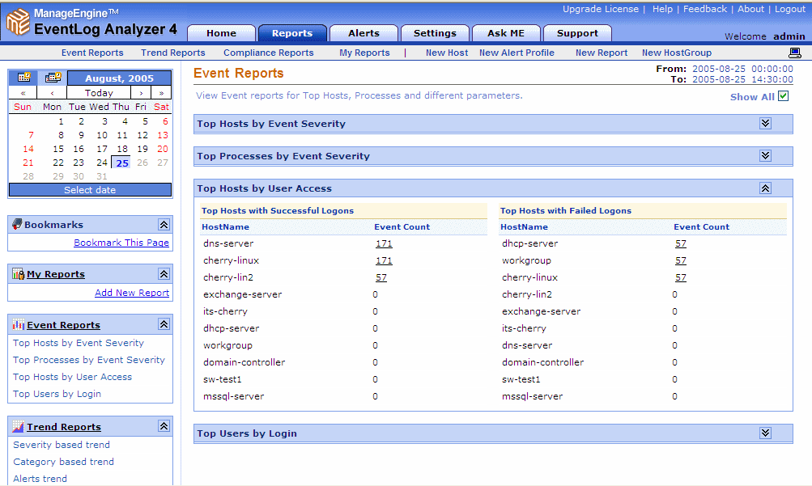

Custom Reports
New reports can be created on event logs received from a select group of hosts, based on specific event filters. Critical servers are monitored and schedules are set up to automatically report on these parameters at regular intervals. The following diagram depicts an example of this report.
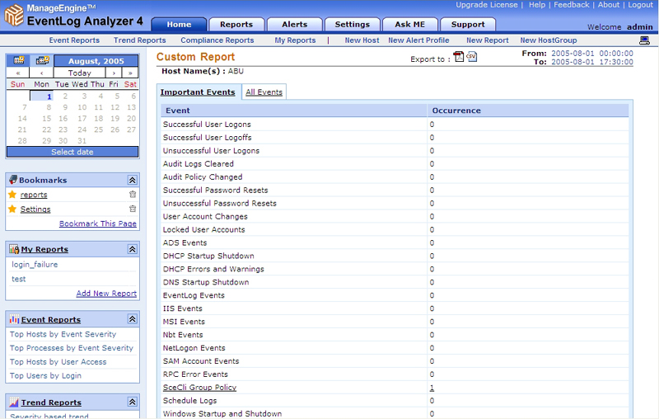

Audit Record Retention (ECRR-1)
<SYSTEM NAME> collect and retain audit data, for at least one year, to support technical analysis relating to misuse, penetration reconstruction, or other investigations, and provide this data to appropriate law enforcement or other investigating agencies.

EventLog Analyzer automatically archives all event logs and syslogs collected from Windows hosts, Routers & Switches, and other syslog devices on the EventLog Analyzer server itself. The default archiving interval creates an archive file every 24 hours. At any time, <SYSTEM NAME> can load archived event logs into the EventLog Analyzer database and generate reports from the event data archived.

The <SYSTEM NAME> data backup procedures include the EventLog Analyzer archive files, which are stored on Tape for at least one year.

audit Trail Protection (ECTP-1)
Access to audit log data can be accomplished in the following ways:
- Physical access to the Device
- Online access through the EventLog Analyzer server
Access to audit logs is controlled through a combination of access restrictions on the individual devices and through the EventLog Analyzer User Management subsystem. Only the below classes of personnel are allowed access to audit logs. No other access is permitted

- System Administrator – Read access only
- IAO – authorized to delete the audit log after it is archived

It is particularly important to ensure the integrity of audit trail data against modification. The audit trail files need to be protected since, for example, intruders may try to "cover their tracks" by modifying audit trail records.

The following table lists the audit log file locations and the associated access permissions:

Device | Audit Location | Access Controls
 |  | Authorized Administrators only. Must have valid account on Cisco device.
 |  | Authorized Administrators only. Must have valid account on Cisco device.
 |  | Authorized Administrators only. Must have valid account on Cisco device.
Administrator – READ
Auditors group -- FULL
Administrator – READ
Auditors group – FULL
Administrator – READ
Auditors group -- FULL
Protected by Windows ACL and EventLog Analyzer user roles.
Administrator – READ
Auditors group -- FULL

Audit Trail Backup (ECTB-1)
<SYSTEM NAME> has integrated the EventLog Analyzer data into the daily and weekly backup plan. All data is backed up to Tape and is available for restoration.

Audit Review (ECAT-1, ECAT-2)
The following types of Audit Trail reviews are implemented:

- Audit Trail Review After an Event. Following a known <SYSTEM NAME> problem, a known violation of existing requirements by a user, or some unexplained system or user problem, the <SYSTEM NAME> system administrator will review the audit trails. Review by the application/data owner would normally involve a separate report, based upon audit trail data, to determine if their resources are being misused.

- Periodic Review of Audit Trail Data. <SYSTEM NAME> system administrators will review audit trail records on a daily basis.

- Real-Time Audit Analysis. Traditionally, audit trails are analyzed in a batch mode at regular intervals (e.g., daily). Audit records are archived during that interval for later analysis. EventLog Analyzer will be used in a real-time for audit review.

Appendix A – Windows Event ID Descriptions

The following table details the event IDs, and the categories to which they belong.

Event ID # |  | Event Description
Audit Privilege Use (Success and Failure)
576 | Special privileges assigned to new logon
577 | Privileged Service Called
578 | Privileged object operation
Audit Process Tracking (Success and Failure)
592 | A new process has been created
593 | A process has exited
594 | A handle to an object has been duplicated
595 | Indirect access to an object has been obtained
Audit System Events (Success and Failure)
512 | Windows NT is starting up
513 | Windows NT is shutting down
514 | An authentication package has been loaded
515 | A trusted logon process has registered
516 | Loss of some audits
517 | The audit log was cleared
518 | A notification package has been loaded
Audit Logon Events (Success and Failure)
528 | A user successfully logged on to a computer
529 | The logon attempt was made with an unknown user name or bad password
530 | The user account tried to log on outside of the allowed time
531 | A logon attempt was made using a disabled account
532 | A logon attempt was made using an expired account
533 | The user is not allowed to log on at this computer
534 | The user attempted to log on with a logon type that is not allowed
535 | The password for the specified account has expired
536 | The Net Logon service is not active
537 | The logon attempt failed for other reasons
538 | A user logged off
539 | The account was locked out at the time the logon attempt was made
540 | Successful Network Logon
541 | IPSec security association established
542 | IPSec security association ended
543 | IPSec security association ended
544 | IPSec security association establishment failed
545 | IPSec peer authentication failed
546 | IPSec security association establishment failed
547 | IPSec security association negotiation failed
682 | A user has reconnected to a disconnected Terminal Services session
683 | A user disconnected a Terminal Services session without logging off
Audit Account Logon Events (Success and Failure)
672 | An authentication service (AS) ticket was successfully issued and validated
673 | A ticket granting service (TGS) ticket was granted
674 | A security principal renewed an AS ticket or TGS ticket
675 | Pre-authentication failed
676 | Authentication Ticket Request Failed
677 | A TGS ticket was not granted
678 | An account was successfully mapped to a domain account
680 | Identifies the account used for the successful logon attempt
681 | A domain account log on was attempted
682 | A user has reconnected to a disconnected Terminal Services session
683 | A user disconnected a Terminal Services session without logging off
Audit Account Management Events (Success and Failure)
624 | User Account Created
625 | User Account Type Change
626 | User Account Enabled
627 | Password Change Attempted
628 | User Account Password Set
629 | User Account Disabled
630 | User Account Deleted
631 | Security Enabled Global Group Created
632 | Security Enabled Global Group Member Added
633 | Security Enabled Global Group Member Removed
634 | Security Enabled Global Group Deleted
635 | Security Disabled Local Group Created
636 | Security Enabled Local Group Member Added
637 | Security Enabled Local Group Member Removed
638 | Security Enabled Local Group Deleted
639 | Security Enabled Local Group Changed
640 | General Account Database Change
641 | Security Enabled Global Group Changed
642 | User Account Changed
643 | Domain Policy Changed
644 | User Account Locked Out
645 | Computer object added
646 | Computer object changed
647 | Computer object deleted
648 | Security Disabled Local Group Created
649 | Security Disabled Local Group Changed
650 | Security Disabled Local Group Member Added
651 | Security Disabled Local Group Member Removed
652 | Security Disabled Local Group Deleted
653 | Security Disabled Global Group Created
654 | Security Disabled Global Group Changed
655 | Security Disabled Global Group Member Added
656 | Security Disabled Global Group Member Removed
657 | Security Disabled Global Group Deleted
658 | Security Enabled Universal Group Created
659 | Security Enabled Universal Group Changed
660 | Security Enabled Universal Group Member Added
661 | Security Enabled Universal Group Member Removed
662 | Security Enabled Universal Group Deleted
663 | Security Disabled Universal Group Created
664 | Security Disabled Universal Group Changed
665 | Security Disabled Universal Group Member Added
666 | Security Disabled Universal Group Member Removed
667 | Security Disabled Universal Group Deleted
668 | Group Type Changed
669 | Add SID History (Success)
680 | Add SID History (Failure)
Audit Object Access (Success and Failure)
560 | Access was granted to an already existing object
561 | A handle to an object was allocated
562 | A handle to an object was closed
563 | An attempt was made to open an object with the intent to delete it
564 | A protected object was deleted
565 | Access was granted to an already existing object type
566 | Object Operation
608 | A user right was assigned
Audit Policy Change (Success and Failure)
609 | A user right was removed
610 | A trust relationship with another domain was created
611 | A trust relationship with another domain was removed
612 | An audit policy was changed
613 | IPSec policy agent started
614 | IPSec policy agent disabled
615 | IPSec policy changed
616 | IPSec policy agent encountered a potentially serious failure
617 | Kerberos policy changed
618 | Encrypted data recovery policy changed
620 | Trusted domain information modified
768 | A collision was detected between a namespace element in two forests
Audit Directory Service Access (Success and Failure)
565 | Information about accessed objects in AD

